Phase 3 – Ride Sharing Event Pipeline Walkthrough
Objective
The objective of Phase 3 is to design and implement a simple event-driven ride-sharing pipeline using Apache Kafka. The system simulates ride events, filters completed rides, calculates driver earnings, and displays the top-performing drivers.

Architecture Overview
The pipeline consists of three Kafka topics and four Python applications.
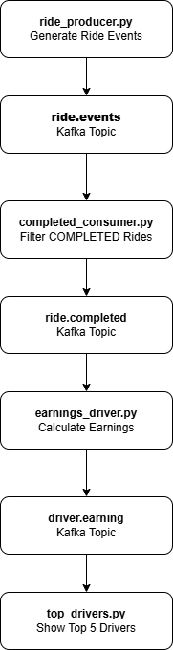

Components
1. ride_producer.py
Purpose
Simulates ride-sharing events and publishes them to the Kafka topic ride.events.
Event Structure
Each ride event contains:
- ride_id
- driver_id
- rider_id
- status
- latitude
- longitude
- timestamp
Sample Event
{
"ride_id": "RIDE-101",
"driver_id": "DRV-05",
"rider_id": "USR-12",
"status": "COMPLETED",
"lat": 12.9716,
"lon": 77.5946,
"timestamp": "2026-05-01T10:00:00Z"
}
Output
The producer continuously sends ride events to the ride.events topic.
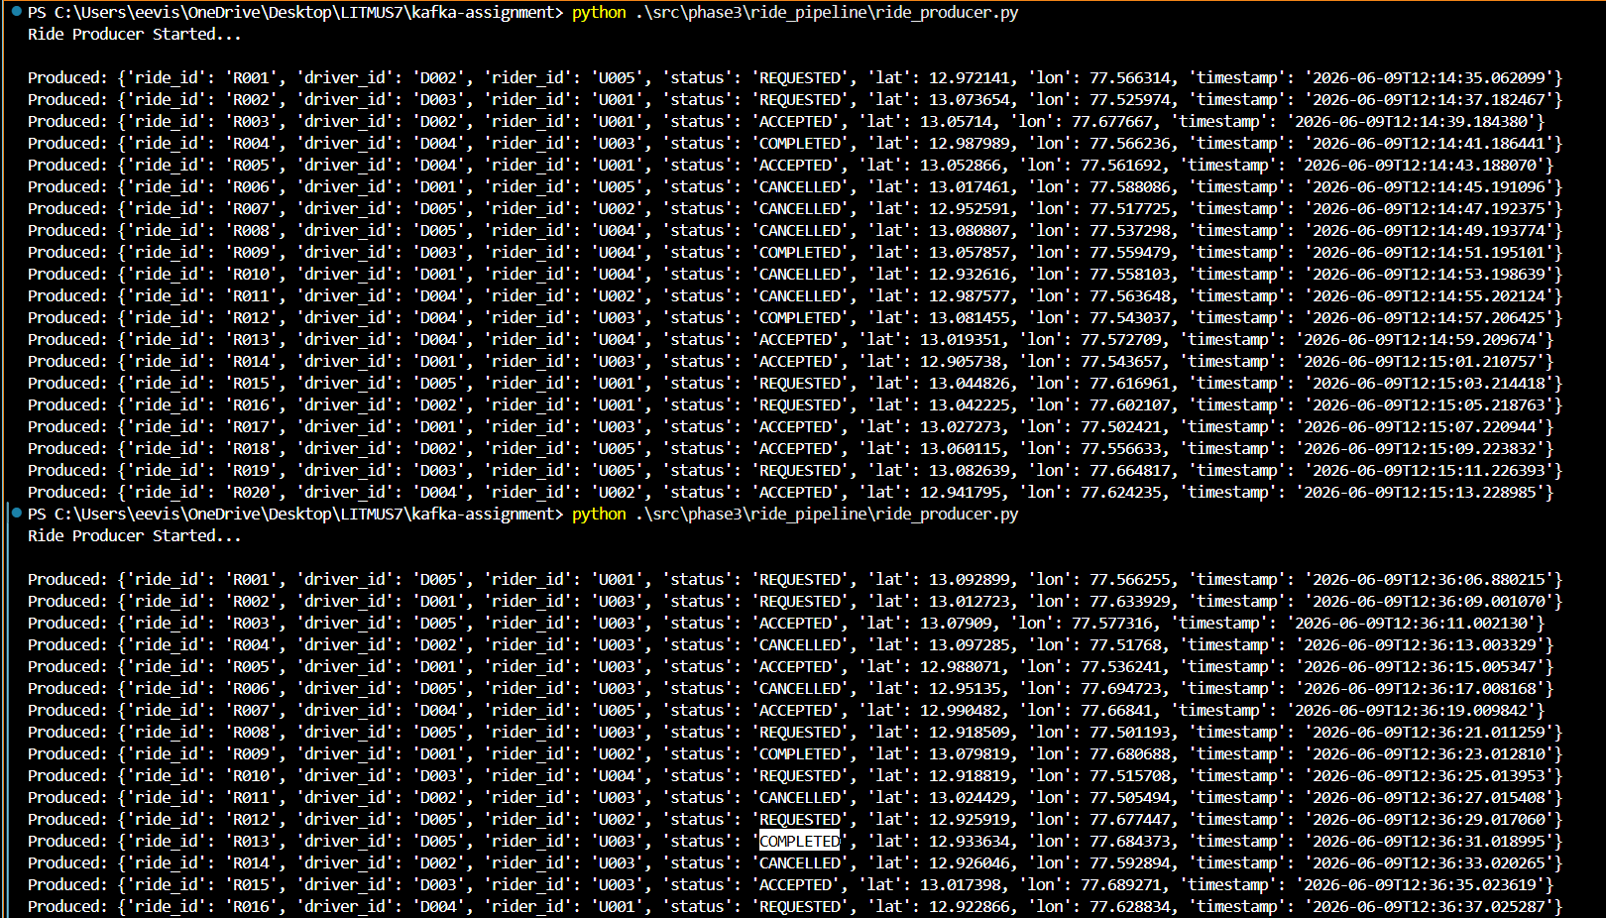

2. ride.events Topic
Purpose
Acts as the primary event stream containing all ride events generated by the producer.
Contains
- REQUESTED rides
- ACCEPTED rides
- COMPLETED rides
- CANCELLED rides

3. completed_consumer.py
Purpose
Consumes events from the ride.events topic and filters only rides whose status is COMPLETED.
Processing Logic
- Read event from ride.events
- Check ride status
- If status equals COMPLETED
  - Publish event to ride.completed
- Ignore all other statuses
Example
Output:
Published to ride.completed
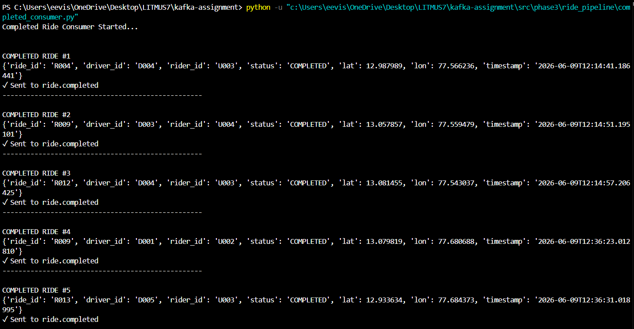

4. ride.completed Topic
Purpose
Stores only completed ride events.
Benefit
Separates completed rides from other ride statuses and simplifies downstream processing.

5. earnings_driver.py
Purpose
Calculates driver earnings based on completed rides.
Business Rule
Each completed ride earns the driver a fixed amount of $5.
Processing Logic
- Consume from ride.completed
- Extract driver_id
- Increment completed ride count
- Calculate earnings
Formula:
Earnings = Completed Rides × $5
Example
Driver DRV-05 completes 3 rides:
Completed Rides = 3
Earnings = $15
Output
Results are published to driver.earnings.
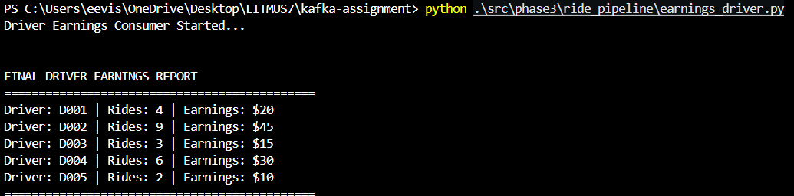

6. driver.earnings Topic
Purpose
Stores aggregated driver statistics.

7. top_drivers.py
Purpose
Displays the top-performing drivers based on completed rides.
Processing Logic
- Read records from driver.earnings
- Sort by completed ride count
- Display top 5 drivers
Sample Output
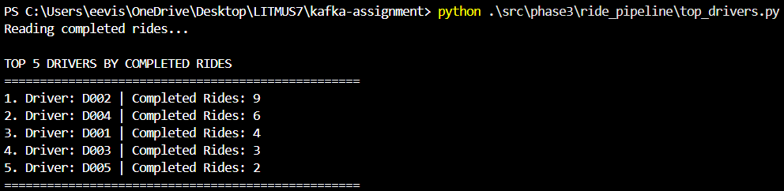
Execution Steps
Step 1
Start Kafka and create required topics:
- ride.events
- ride.completed
- driver.earnings

Step 2
Run the producer:
python .\src\phase3\ride_pipeline\ride_producer.py

Step 3
Run the completed ride consumer:
python .\src\phase3\ride_pipeline\completed_consumer.py

Step 4
Run the earnings aggregation consumer:
python .\src\phase3\ride_pipeline\earnings_driver.py

Step 5
Run the reporting application:
python .\src\phase3\ride_pipeline\top_drivers.py

Key Learnings
- Event-driven architecture using Kafka
- Topic-based communication between services
- Stream filtering using consumers
- Aggregation and stateful processing
- Real-time analytics using Kafka topics

Conclusion
This implementation demonstrates a simplified ride-sharing analytics pipeline built using Apache Kafka. Events are generated, filtered, processed, aggregated, and finally presented as driver performance statistics.

